|  |  |
| --- | --- |
| **WC Logo.emf** | **Staff Report to the County Commission**  *Weber County Planning Division* |
|  | |

****Synopsis****

****Application Information****

**Application Request:** Request for final approval for a conditional use request for Winston Park, a Planned Residential Unit Development consisting of 54 residential units, and two open space parcels, totaling approximately 40.259 acres.

**Type of Decision: Administrative**

**Applicant: Wade Rumsey**

**Agenda Date: January 19, 2021**

**Approximate Address:** 3701 West 1800 South

**Project Area:** 40.259 Acres

**Zoning:** A-1

**Existing Land Use:** Residential/Agricultural

**Proposed Land Use:** Residential-

**Parcel ID:** 15-078-0002

**Township, Range, Section:** T6N, R2W, Section 28 NE

****Adjacent Land Use****

**North:** 1800 South St. **South:** Agricultural

**East:** Agricultural **West:** Agricultural/Residential

****Staff Information****

**Report Presenter: Tammy Aydelotte**

[taydelotte@co.weber.ut.us](mailto:taydelotte@co.weber.ut.us)

**801-399-8794**

**Report Reviewer: RG**

Applicable Ordinances

* Title 101, Chapter 1 General Provisions, Section 7, Definitions
* Title 104, Zones, Chapter 5 Agricultural A-1 Zone
* Title 108, Chapter 1 Design Review
* Title 108, Chapter 4 Conditional Uses
* Title 108, Chapter 5 Planned Residential Unit Development
* Title 108, Chapter 8 Parking and Loading Space, Vehicle Traffic and Access Regulations

Summary and Background

1/12/2021 – Western Weber Planning Commission recommended final approval for the conditional use of a Planned Residential Unit Development. Receiving a recommendation for approval from the Planning Commission is the first step in the PRUD process.

Under the PRUD ordinance, a development is able to receive additional lots than what the zone normally allows. The extra density is called Bonus Density. **The applicant is eligible to receive a 30 percent bonus density based on the preservation of 30% of the adjusted gross acreage as open space, as defined in 101-1-7**. **However, if the applicant preserves open space area above 30 percent, the county may grant a bonus density of up to 50 percent.** Applicant is proposing to dedicate 46% of gross adjusted acreage as open space, and is requesting 42% bonus density. Under the PRUD ordinance the applicant has chosen to do the following to warrant the requested additional density:

“The county may award bonus densities based on an accumulation of any combination of the following:

1. (a) If a PRUD provides and implements an approved roadway landscape and design plan that includes, but is not necessarily limited to, vehicle and pedestrian circulation, lighting, and street trees of an appropriate species, size of at least a two-inch caliper, and quantity of not less than eight trees for every 100 feet of road length, **up to 20 percent bonus density may be granted.**

…..

2. (d) If a PRUD provides a common area that offers easily accessible amenities such as trails, parks, or community gardens, that are open for use by the general public, **up to a 15 percent bonus density may be granted**.

…..

1. (g) 1. For a parcel containing at least ten acres but fewer than 20 acres, **up to a 15 percent bonus density may be granted.** The larger open space parcel contains over 15 acres, thus satisfying this requirement.

With the combination of the above bonus density options, the applicant may be able to receive up to **46 percent bonus density**, however, the request is for 42% (14 additional lots, on top of the 38 lots the applicant is currently entitled to).

Analysis

*General Plan:* The proposal conforms to the West Central Weber County General Plan by supporting agriculture and encouraging residential cluster style development with a minimum 30% open space.

*Zoning:* The subject property is located in the Agricultural A-1 Zone.

*Lot area, frontage/width and yard regulations*: The purpose and intent of a Planned Residential Unit Development (PRUD) is intended to *“allow for diversification in the relationship of various uses and structures to their sites and to permit more flexibility of such sites and to encourage new and imaginative concepts in the design of neighborhood and housing projects in urbanizing areas.”* The proposed PRUD utilizes the allowed flexibility to create neighborhoods with lots ranging in size from 0.23 acre lots to .99 acre lots and sized to accommodate single family homes.

The proposal includes the following minimum single family development standards:

* Yard development standards:

Front Yard: 20 feet

Side Yard: 6 feet, 15 feet on a corner lot where the side lot line is adjacent to a street.

Rear Yard: 20 feet

* Maximum Building Height:
  + Single Family: 35’ (average building height)

Based on the allowed flexibility of a PRUD, the proposed layout, lot configurations and lot sizes are acceptable. In order to provide clear site standards at intersecting streets throughout the development, staff recommends adding to the minimum setback standards on the preliminary and final subdivision plats a setback for “Side, facing street corner lot”. This setback should be a minimum of 15 feet. A condition of approval has been added to staff’s recommendation to ensure the additional “Side, facing street corner lot: 15 feet” setback standard is added to the preliminary and final subdivision plats for review and approval as required per LUC §104-5-7.

During each individual phase, the County review agencies will be able to more thoroughly vet the preliminary and final development details to ensure that all conditions of approval and the applicable subdivision standards are met. Applicant is planning one phase for this development.

*Conditional Use Review:* The proposed PRUD is conditionally allowed in the A-1 zone. A review process has been outlined in LUC §108-4-3 to ensure compliance with the applicable ordinances and to mitigate anticipated detrimental effects.

As a requirement of the conditional use permit, the applicant has provided a “Will-Serve Letter” from Taylor West Weber Water Improvement District and is working with Weber County Engineering regarding additional infrastructure for Central Weber Sewer District for culinary and waste water services. If the applicant has not already annexed into the Central Weber Sewer District, it must be completed prior to final approval of the subdivision within this proposed PRUD. The applicant, during the subdivision phase, will be required to provide proof of secondary water availability. The applicant has provided the required material to facilitate a thorough review of the proposed project including the project narrative, vicinity map, conceptual layout, and proposed landscaping for the development.

The general requirements for consideration by the County Commission for the proposed planned residential unit development include items such as the architectural design of buildings and their relationship on the site and development beyond the boundaries of the proposal; which streets shall be public and which shall be private; the entrances and exits to the development and the provisions for internal and external traffic circulation and off-street parking; the landscaping and screening as related to the proposed uses within the development and as a means of its integration into its surroundings; lighting and the size, location, design, and quality of signs if any; the residential density of the proposed development and its distribution as compared with the residential density of the surrounding lands, either existing or as indicated on the zoning map or general plan proposals of the county as being a desirable future residential density.

*Bonus Density Request:* The County may grant a bonus density of up to 30 percent if the applicant preserves open space area equal to or greater than 30 percent of the PRUD's adjusted gross acreage per LUC §108-5-5(c)(2). The proposal meets this bonus density requirement. If the applicant preserves open space area above 30 percent, the county may grant a bonus density of up to 50 percent; however, **overall bonus density potential shall be no greater than a percentage equal to the percentage of the PRUD's total area preserved as open space**. The proposal dedicates 16.320 acres of open space which is **46%** of the adjusted gross acreage (40.259 total area-4.873 acres of roads = 35.386 acres developable area); therefore qualifying for up to the 46 percent bonus density.

With the requested **42** percent bonus density, the applicant will be able to add an additional **16** units to the **38** base units for an overall density of **54** residential units.

*Review Agencies:* Due to the conceptual nature of the proposal, the Weber County Surveyor’s Office has not reviewed the proposal. The Weber Fire District has reviewed this project, requesting additional information. The Engineering Division has not yet reviewed the proposal. A condition of approval has been made part of the Planning Staff’s recommendations to ensure that any conditions of the applicable reviewing agencies are strictly adhered to.

*Public Notice:* Public notice is not required for conditional use applications.

Summary of County Commission Considerations

* Does this proposal comply with the applicable PRUD ordinance?
* In considering the proposed planned residential unit development, the County Commission shall review and consider the following, as applicable:
  + *The architectural concept of buildings and their relationship on the site and development beyond the boundaries of the proposal.*
  + *Which streets shall be public and which shall be private; the entrances and exits to the development and the provisions for internal and external traffic circulation and off-street parking.*
  + *The landscaping and screening as related to the proposed uses within the development and their integration into the surrounding area.*
  + *The residential density of the proposed development and its distribution as compared with the residential density of the surrounding lands, either existing or as indicated on the zoning map or general plan proposals of the county as being a desirable future residential density.*

Planning Commission Recommendations

* The fire access road be asphalt, for ease of maintenance.
* CC&R’s for the subdivision specifically not allow for basements within this development.
* Fencing be installed between the residential lots and the open space area designated for agricultural use.

Staff Recommendation

Staff recommends approval of the request for a conditional use request for Winston Park, a Planned Residential Unit Development consisting of 54 residential units, and two open space parcels (1.275 acres and 15.046 acres) used for agricultural purposes.

1. The following setback standard shall be added to the final subdivision plats for review and approval: Front – 20’, side – 6’, rear – 20’, corner lot with a side facing a street – 15’.
2. Street light design shall be approved by Planning Department prior to issuance of a conditional use permit.
3. Sidewalk, curb and gutter will be installed along the applicant’s frontage of 1800 South as well as along the roads within the subdivision.
4. CC&R’s will not allow basements within this PRUD.

This recommendation is based on the following findings:

1. The proposed PRUD conforms to the West Central Weber County General Plan.
2. The PRUD is intended to allow for more flexibility of residential building sites.
3. The building uses, locations, lot area, width, yard, height and coverage regulations proposed are acceptable as shown on the conceptual drawings.
4. Up to a 50 percent bonus density may be granted based on the following:
5. If the applicant preserves open space area above 30 percent, the county may grant a bonus density of up to 50 percent; however, overall bonus density potential shall be no greater than a percentage equal to the percentage of the PRUD's total area preserved as open space. The proposal dedicates approximately 17 acres of open space (two parcels) which is 50% of the adjusted gross acreage; therefore qualifying for up to the 50 percent bonus density.
6. The proposal will not be detrimental to the public health, safety, or welfare.
7. The proposal will not deteriorate the environment of the general area so as to negatively impact surrounding properties and uses.

Exhibits

1. Project Narrative and Bonus Density Calculations
2. Winston Park PRUD Conceptual Plan
3. Proposed Lot Layout
4. Fire District Approval

Location Map

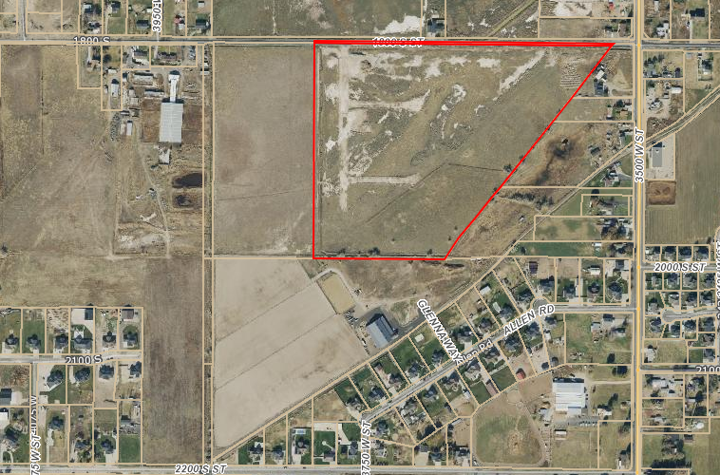

Subject Property

Exhibit A-Project Narrative

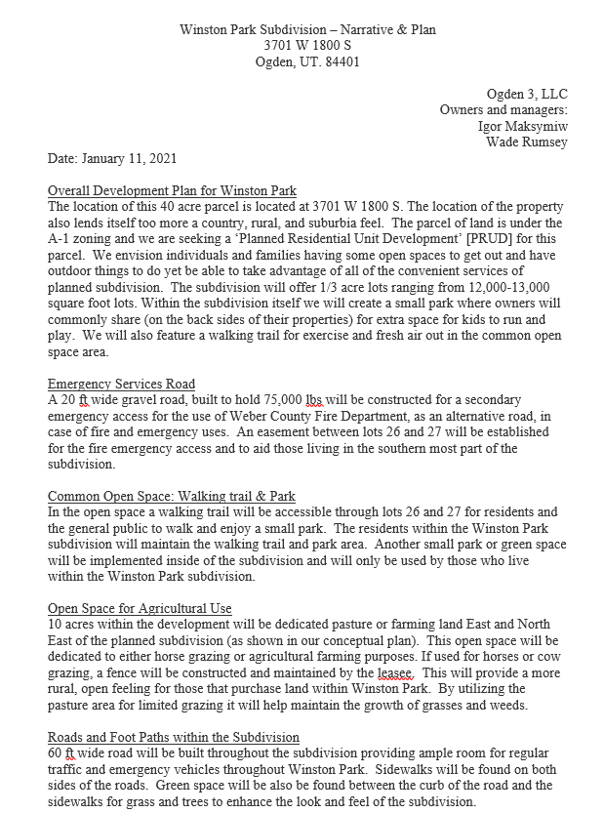

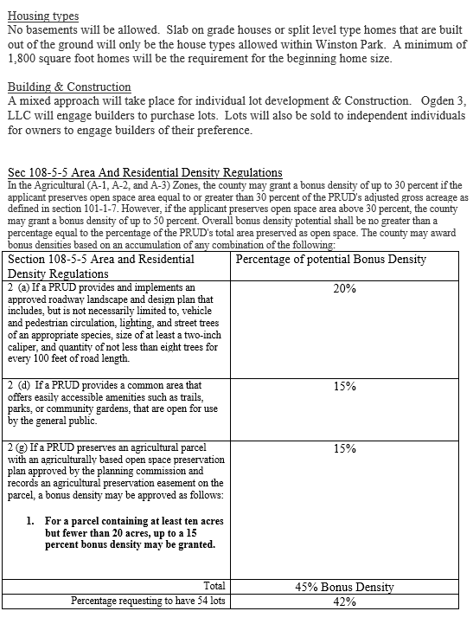

Exhibit B-Winston PRUD Landscaping Plans

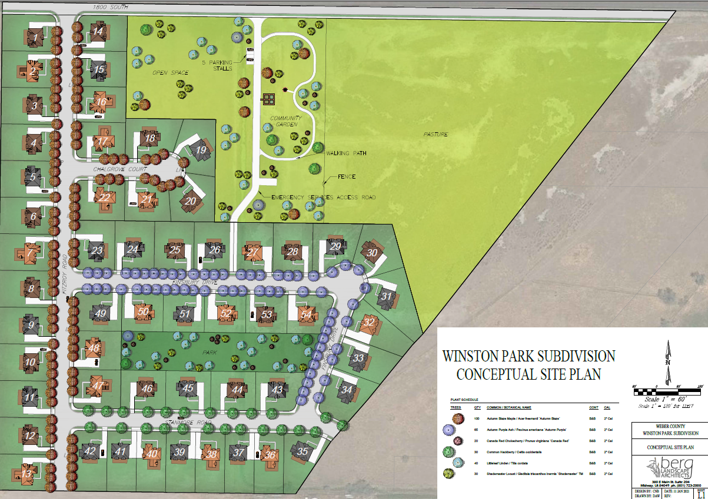

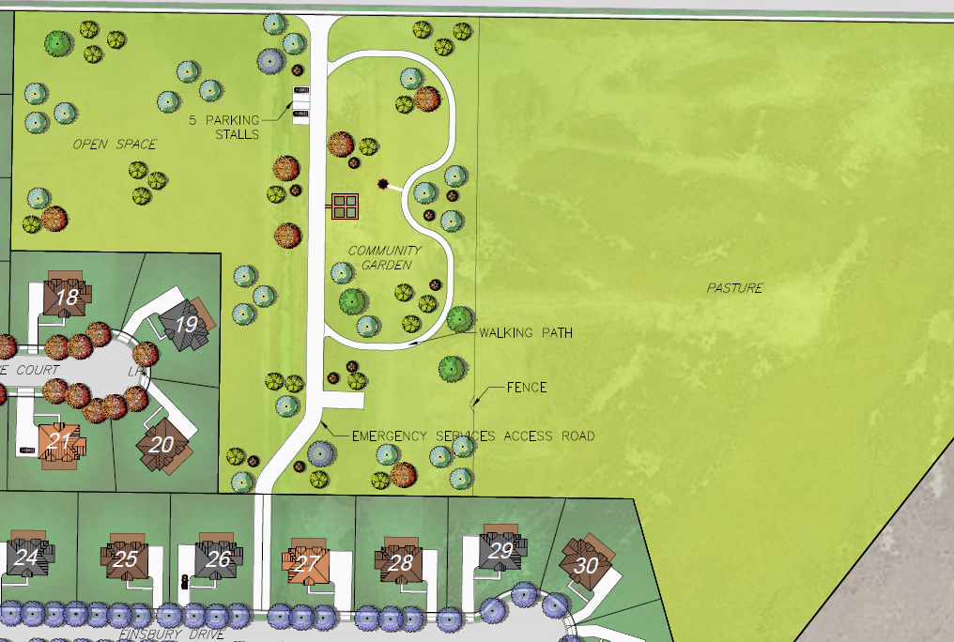

Exhibit C-Proposed Lot Layout

